ALISAR SOLUTIONS

Bowes Formula One Card Membership System for Catering Services

Tilemachos Papas

Level 4: Software Development

Professor: Bilikha Okoye

Due: Jan 2019

# Terms of Reference

# Summary (Abstract)

# Table of Contents

Terms of Reference 2

Summary (Abstract) 3

Table of Contents 4

Introduction 5

Methodology 6

Introduction 6

Tools 6

Languages 6

Diagrams 6

Prototypes 6

Database 6

Activity Diagram 6

Sequence Diagrams 6

Class Diagrams 6

Results 7

Discussion 8

Conclusion 9

Appendices 10

Bibliography 11

Acknowledgements 12

Glossary of Technical Terms 13

# Introduction

Nurbek Saparkhojayev and Selim Guvercin (2012) stated that Radio Frequency Identification (RFID) chips could be used in student id cards to transfer data over radio frequency. In this project, we are assuming that, the same technology is being used by both First Catering Service & Bowes Formula One for employees’ access control. Firstly, we will be looking at how First Catering Service handles its employees’ data, and stores that to the back end. Next, we will be assessing how FCS can offer its catering services to BFO, while trying to address security issues.

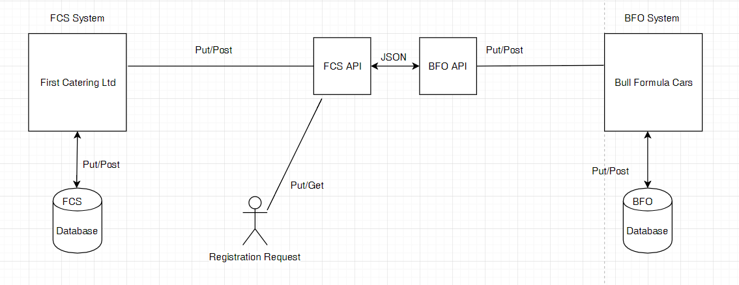

Figure : Architectural Diagram

Furthermore, we will be breaking down these systems into UML diagrams & architectural diagrams in order to comprehend the technicality involved.

The functionalities that we will be focusing on in this project, are the following:

* User Registration (optional)
* Adding users to the FCS database via company CSV Upload
* Session control
* User login
* Company login
* Payments
* Card Top-Up
* Listing page for employees
* Unique token generation
* FCS Contact us

In order to achieve this, we will be using the AGILE SCRUM methodology for project management. During which, the author will be assuming many roles.

# Methodology

## Introduction

As previously mentioned, we will be using the AGILE SCRUM methodology to achieve this project. This project will have a lifespan of 3 months. During which, each sprint will be a week long. The requirement for this project is to enable BFO to be able to use the FCS system for their catering needs. This requirement will be broken down into user stories in order to size the tasks that will go into each sprint (See APENDIX)

## Tools

* Draw.io
* Mockingbird
* Visual Studio
* PhP My Admin
* XAMMP
* APACHE
* MySQL
* Microsoft Word
* Microsoft Excel

## Languages

* PHP 7.2
* SQL
* HTML5
* CSS3
* JavaScript ES6
* BOOTSTRAP
* jQuery
* AJAX

## Diagrams

### Prototypes

### Database

### Activity Diagram

### Sequence Diagrams

### Class Diagrams

# Results

# Discussion

# Conclusion

# Appendices

# Bibliography

P, S. (2012). A Rfid Based Attendance Tracking System. *IOSR Journal of Environmental Science, Toxicology and Food Technology*, 2(2), pp.12-17.

# Acknowledgements

# Glossary of Technical Terms